“My World” By Viktor Grebennikov

CHAPTER 5 - Introduction (translated from Russian)
The Natural Phenomena of AntiGravitation and Invisibility in Insects
due to the Grebennikov Cavity Structure Effect (CSE)

Introduction
by Iu. N. Cherednichenko, Senior Researcher, Biophysics Laboratory, Institute of Human Pathology and Ecology, Russian Academy of Medical Science

Viktor Stepanovich Grebennikov is a naturalist, a professional entomologist, an artist-simply put, an intellectual with a wide range of interests and pursuits. He is known to many as the discoverer of the Cavernous Structures Effect (CSE). But very few people are familiar with his other discovery, one that also borrows from Nature and its innermost secrets.

Back in 1988 he discovered anti-gravitational effects of the chitin shell of certain insects. But the most impressive concomitant phenomenon discovered at the same time was that of complete or partial invisibility or of distorted perception of material objects entering the zone of compensated gravity. Based on this discovery, the author used bionic principles to design and build an anti-gravitational platform for dirigible flights at the speed of up to 25 km/min. Since 1991-92 he has used this device for fast transportation.

Bio-gravitational effects are a wide spectrum of natural phenomena, apparently not confined to just a few species of insects. There is much empirical data to support the possibility of a lowered weight or complete levitation of material objects as a result of directed psychophysical human action (psychokinesis)-e.g. levitation of yogi practicing transcendental meditation according to the Maharishi method. There are known cases of mediums levitating during spiritistic sessions. However, it would be a mistake to think that such abilities are only found in people who are gifted by nature.

I am convinced that these abilities are an understudied biological regularity. As is known, human weight significantly drops in the state of somnambulistic automatism (sleepwalking). During their nocturnal journeys, 80-90 kg sleepwalkers are able to tread on thin planks, or step on people sleeping next to them without causing the latter any physical discomfort (other than fright). Some clinical cases of non-spasmodic epileptic fits often result in a short-term reversible transformation of personality (people in such state are commonly referred to as "possessed"), whereby a skinny, exhausted girl or a ten-year-old boy, acquire the physical prowess of a trained athlete.

Currently this psychological phenomenon is known as multiple-personality syndrome because it significantly differs from the classical complex of epileptic symptoms. Such clinical cases are well known and well documented. However, phenomena accompanied by a change in the weight of humans or of material objects are not confined to functional pathologies of the organism.

Healthy people in the state of acute psychological stress caused by a life-threatening situation or an overpowering motivation to achieve a vitally important goal, have the ability to spontaneously overcome obstacles insurmountable in their normal condition-e.g. to lift enormous weights, etc. These phenomena are commonly explained by an extreme mobilization of muscular strength, but precise calculations do not agree with such hypotheses. Apparently, athletes (high jumpers, weightlifters, runners) have particularly developed bio-antigravitational mechanisms.

Their athletic performance is mostly (if not wholly) determined not so much by the rigor of their training as by their psychological preparedness. If an accurate scientific task of studying the anomalies of the human weight in various psycho-physiological states were ever set up and technical means of dynamic weight monitoring created, we would then have objective data on this unusual phenomenon. There is also evidence of other phenomena of short-term mass increase in biological objects, including humans, that are not related to mass transfer.

V. S. Grebennikov's book has high literary merit and includes the author's own illustrations. It is a kind of a "dactylogram" for his system of spiritual values, his environmental outlook, and his entomological autobiography. Many readers are likely to perceive the book as nothing more than a popularized summary of the entomologist's 60-year experience of scientific observations, peppered with some elements of science fiction. But such a conclusion would be deeply erroneous. As Viktor Stepanovich's friend and as someone with an intimate knowledge of his work (our homes are only 10km apart), I can vouch I have never met a more careful, conscientious, honest, and talented experimental scientist.

Grebennikov is also widely known in the so-called scientific underground (i.e. the branch of advanced Russian science constantly persecuted by the official scientific establishment). Thus, a committee for combating pseudoscience, created in Novosibirsk division of the Russian Academy, has victimized many talented members of our local scientific community. The situation is much the same at the Russian Agricultural Academy. It is very easy to lose one's job at a lab (even as its head, regardless of one's degree and title). One only needs to publish an article on, for example, the evolutionary significance of antigravitational mechanisms in insects.

But I am convinced that discoveries of such proportions must not be buried in manuscripts just because pragmatism still rules science. Let this book be nothing but "science fiction" for those at the top. Each person has his own beliefs. But he who has eyes shall see. Catastrophism in both the evolution of living nature and in the nature of human knowledge is actually a drastic destruction of old belief systems-a destruction that runs ahead of theoretical prognostications. A fanatical faith and idol-worship links our contemporary academic science with pagan religion. But a harmonious development (in the sense of Pavel Florensky's pneumatosphere) would not be possible without breaking old stereotypes in the process of mastering the wisdom and experience of older generations.

CHAPTER 5 - Flight (translated from Russian)


A quiet evening in the steppe. The sun's red disk has already touched the faraway, misty horizon. It is too late to get back home-I've stayed too long here with my insects and am preparing to spend the night in the field. Thank goodness I still have water in the flask and some mosquito repellent-one needs it here, what with hosts of gnats on the steep shore of this salty lake.

I am in the steppes, in Kamyshlovo valley. It used to be a mighty tributary of the Irtysh, but the ploughing of the steppes and deforestation turned the river into a deep broad gully with a string of salty lakes, like this one. There is no wind. Pods of ducks gleam over the evening lake, sandpipers are also heard in the distance.

The high, pearl-colored sky stretches over the calming world of the steppe. How good it is to be out here, in the open country!
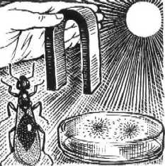
I settle for the night on the very edge of the steep, on a grassy glade. I spread out my coat, put my backpack under the head, and before lying down, collect a few dry cakes of cow manure, and light them up. The romantic, unforgettable smell of bluish smoke slowly spreads across the dozing steppe. I lie down on my simple bed, stretch my tired legs and anticipate yet another wonderful night in the country.

The blue smoke quietly takes me to the Land of Fairy Tales; sleep comes fast. I become very small, the size of an ant, then enormous, like the sky, and am about to fall asleep. But why is it that today these "pre-sleep transformations" of my bodily dimensions are somewhat unusual, too strong? A new sensation has mixed in-a sensation of falling, as though the high cliff has been snatched away from under my body, and I am falling into an unknown, terrible abyss!

Suddenly I see flashes. I open my eyes, but they don't go away-they are dancing on the pearl-and-sliver evening sky and on the grass. I get a strong, metallic taste in my mouth, as though I pressed my tongue to the contact plates of a small electric battery. My ears start ringing... I distinctly hear the double beats of my own heart.

How can one sleep when such things are going on!

I sit up and try to drive away these unpleasant sensations, but nothing comes out of my efforts. The only result is that the flashes are no longer wide and blurred but sharp and clear, like sparks or perhaps small chains; they make it hard to look around. Then I remember: I had very similar sensations a few years ago in Lesochek, or to be more precise, in the Enchanted Grove [the author is referring to localities of an entomological preserve in Omsk Region].

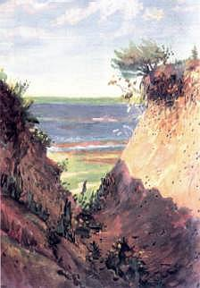
I have to get up and walk around the lakeshore. Does it feel like this everywhere around here? No: here, a meter from the edge, I feel a clear effect of "something", while ten meters further into the steppe the effect clearly disappears.

It becomes a bit frightening: I am alone in the deserted steppe, by the "Enchanted Lake". I should quickly pack up and clear out. But my curiosity takes over: what is this, really? Could it be that the smell of lake water and slime is doing this to me? I go down, under the steep and sit down by the water. The thick, sweetish smell of sapropel-rotted remains of algae-is enveloping me like in a mud spa. I sit there for five, ten minutes-no unpleasant sensations. It would be suitable to sleep here, if it weren't so wet.

I climb the steppe-same old story! My head is spinning, I again get that "galvanic", sour taste in the mouth and feel as though my weight is changing-I am at one moment incredibly light, and unbearably heavy at the next. I see flashes in my eyes. If it was indeed a "bad spot", some nasty anomaly, then there would be no grass here, and large bees would not be nesting in the loamy steppe.
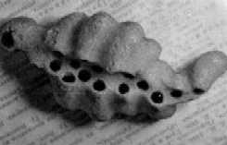
Meanwhile, their nests are all over it-in fact, I was trying to make my bed right above their underground "bee city" in whose depths there is of course a multitude of tunnels, chambers, lots of larvae, cocoons-all of them alive and healthy. I understood nothing that time.

I got up with a headache even before sunrise and, tired, hobbled off toward the road to get a hitch to Isilkul.

That summer I visited the "Enchanted Lake" four more times, at various times of day, and under various weather conditions. By the end of the summer my bees got incredibly busy stuffing their holes with flower pollen - in a word, they were feeling great. Which I wasn't: a meter from the edge of the steppe, above their nests, I again had a set of most unpleasant sensations. Five meters away, I had none... And there was the same old bewilderment: why, why do these bees feel so good here that the entire steppe is dappled with their holes like Swiss cheese, and in places, almost like a sponge?

The solution came many years later, when the bee city in Kamyshlovo valley died: the tillage came to the very edge, which consequently fell off. Now instead of grass and bee holes, there is nothing there but an atrocious heap of mud.

I only had a handful of old clay lumps-fragments of those nests, with multiple chamber cells. The cells were side by side and reminded of small thimbles, or little jugs with narrowing necks.

I already knew that these bees were of the quadruple ring species-that was the number of light rings on their elongated bellies. On my desk, packed with equipment, ant- and grasshopper-houses, bottles with chemicals, and other stuff, I had a wide receptacle filled with these spongy clay lumps. I was about to pick something up and moved my hand over these porous fragments.

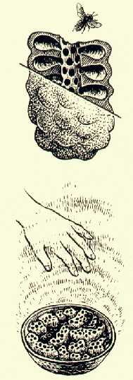
A miracle happened: I suddenly felt warmth emanating from them. I touched the lumps with my hand-they were cold, but above them I felt a clear thermal sensation.

Besides, in my fingers I felt some hitherto unknown jerks, some sort of "tick" as it were. And when I pushed the bowl with the nests to the end of the desk and leaned over it, I felt the same sensation as on the lake-my head was getting lighter and bigger, the body was falling down, the eyes saw rapid flashes, and the mouth tasted an electric battery. I was feeling slightly nauseous...

I put a sheet of cardboard on top of the bowl-the sensation didn't change. A pot lid changed nothing either; it was as if the "something" was cutting right through it. I had to study the phenomenon at once. But what could I do at home, without the necessary physical instruments? I got assistance from many research scientists of various institutes of the Agricultural Academy in Novosibirsk.

But alas, the instruments-either thermometers, or ultrasound detectors, magnetometers and electrometers-did not respond to them in the slightest.

We conducted a precise chemical analysis of the clay-nothing special. The radiometer was also silent... But ordinary human hands, and not just mine, distinctly felt either warmth or a cold draft and a tingle, or sometimes a thicker, stickier environment.

Some people's hands got heavier, others felt theirs were pushed up; some people's fingers and arm muscles got numb, they felt giddy and had profuse salivation.
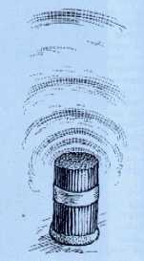
Similar phenomena could be observed in a bunch of paper tubes inhabited by leaf-cutting bees. Each tunnel had a solid row of multi-layered cans of torn leaves, covered with concave lids (also of leaves). Inside the cans there were silk, oval cocoons with larvae and chrysalides.

I asked people who knew nothing of my discovery to hold their hands or faces over the leaf-cutter nests, and took a detailed record of the experiment. The results may be found in my article "On the physical and biological properties of pollinator bee nests" published in the Siberian Bulletin of Agricultural Science, no.3, 1984.

The same article contains the formula of the discovery-a brief physical description of this wonderful phenomenon. Based on the structure of bee nests, I created a few dozen artificial honeycombs-of plastic, paper, metal, and wood. It turned out that the cause of all those unusual sensations was not a biological field, but the size, shape, number, and the arrangement of caverns formed by any solid objects. And as before, the organism felt it, while the instruments were silent.

I called the discovery the Cavernous Structures Effect (CSE) and carried on with my experiments. Nature continued to reveal its innermost secrets one after another...

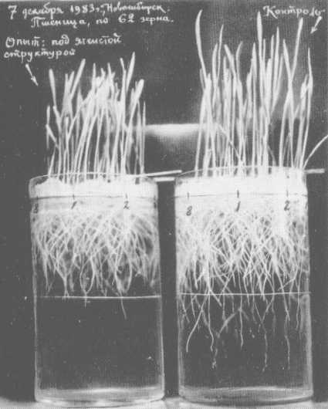
It turned out that the CSE zone inhibits the growth of saprophytic soil bacteria, of yeast and other cultures, as well as wheat grain germination. It also changes the behavior of microscopic algea chlamydospores. Leaf-cutting bee larvae begin to phosphoresce, while adult bees are much more active in this field and finish pollination two weeks earlier.

It turned out that the CSE, like gravitation, could not be shielded-it affected living organisms through walls, thick metal, and other screens. It turned out that if a porous object were moved to another spot, the human would feel the CSE not immediately but in a few seconds or minutes, while the old spot would retain a "trace", or as I called it, a "phantom" perceivable by the hand for hours, and sometimes for months thereafter.

It turned out that the CSE field did not decrease evenly with distance, but surrounded the honeycomb with a system of invisible, yet sometimes clearly perceivable "shells".

It turned out that animals (white mice) and humans entering the zone of the CSE (even a very strong one) soon adapted to it. It couldn't be otherwise: we are everywhere surrounded by caverns large and small: by grids, cells of living and dead plants (as well as our own cells), by bubbles of foam-rubber, foam plastic, foam concrete, rooms, corridors, halls, roofing, spaces between machine parts, trees, furniture, buildings.

It turned out that the CSE "ray" had a stronger impact on living organisms when it was directed away from the sun, and also downwards, facing the Earth's center.
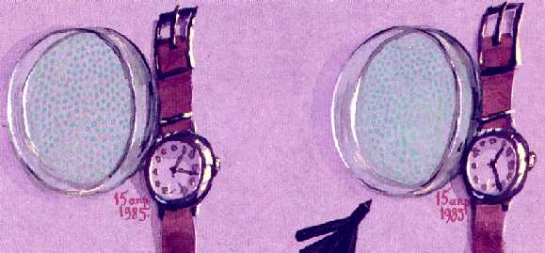
It turned out that clocks - both mechanical and electronic - placed in a strong CSE field, started running inaccurately. Time must also have a part in it. All this was the manifestation of the Will of Matter, constantly moving, transforming, and eternally existing. It turned out that back in the 20s the French physicist Louis des Broglie was awarded the Nobel Prize for his discovery of these waves, and that the latter were used in electronic microscopes.

It turned out... well, many other things transpired in my experiments and research, but they would lead us into solid-state physics, quantum mechanics, elementary-particle physics, i.e. far away from the main characters of our narrative: insects...

Meanwhile, I did manage to devise instruments for an objective registration of the CSE-instruments that accurately reacted to the proximity of insect nests.
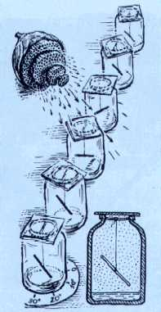
Here they are in the drawing: sealed vessels with straws and burnt twigs, drawing coals-suspended on spider web threads. There is some water at the bottom to counter static electricity hindering experiments in dry air.
If you point an old wasp nest, a bee honeycomb, a bunch of cereal ears to the upper end of the indicator, it slowly moves a few dozen degrees...

There is no miracle here: the energy of scintillating electrons of both multi-cavernous bodies creates a total wave system in space, whereby a wave is energy capable of performing a mutual repulsion of these objects-even through obstacles, such as a thick-walled steel capsule (see photograph).

It is hard to imagine that its armor is powerless to stop waves of a tiny, light wasp nest seen in the picture, and that the indicator inside this heavy, solid capsule "runs away"-sometimes as far as 180 degrees-from this long-vacant nest.

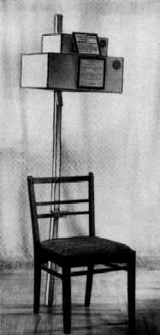
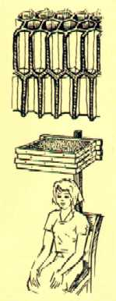
Yet it is so. Those who have doubts are invited to visit the Agroecology Museum near Novosibirsk-you'll see it for yourselves. The same museum displays an always-active honeycomb painkiller. It is a chair with an overhead cap that has a few empty, but intact combs of the honeybee ("dry" honeycombs, in the beekeeper vocab) in it. Anyone who sits in this chair will after a few minutes almost certainly feel something (please write to me what exactly you feel, I'll be grateful), while those with a headache will in just a few minutes say goodbye to the pain-at least for a few hours. My painkillers are successfully used in many parts of the country-I made no secret of my discovery.

The hand will clearly sense the emanation if you take it from below, palm up, to the cap with bee honeycombs. The cap could be made of cardboard, veneer, or better still, of tin plate with tightly sealed seams.

Yet another gift from insects...

This was my reasoning at first: people have been dealing with the honeybee for thousands of years, no one has ever complained of anything unpleasant, except of course stings. I held a dry honeycomb over my head-it was working!

I decided to use a set of six frames. Such was the story of my rather simple discovery. An old wasp nest works quite differently, even though the size and shape of its cells are very close to those of bees.

The important difference was that the honeycomb material, unlike that of wax, is more crumbly and micro-porous: it is paper-like (by the way, it was wasps that invented paper, not people: they scrape old wood fiber and mix it with their sticky saliva).

Walls of the wasp honeycomb are much thinner than those of bees; the cell size and pattern are also different, as is the outer shell, also made of multi-layered, loosely wrapped paper. I had reports of a highly unpleasant effect of a few wasp nests in an attic. And besides, most multi-cell devices and objects that will manifest CSE in the first few minutes have a far from beneficial effect on humans. Honeybee combs are a rare exception. And when in the 1960s we had bumblebees living in our Isilkul apartment, I often observed the following.

A young bumblebee on its first trip away from the hive did not take the trouble to remember the entrance and would spend hours wandering around the windows of our house and of a similar-looking house nearby. And in the evening, giving up on its poor visual memory, it would land on the brick wall, precisely outside the hive and would try to break right through it. How did the insect know that right there, four meters away from the entrance, and a meter and a half below, behind the thick, half-meter wall was its home nest? At the time I was lost in conjectures, but now I know exactly why the bumblebee behaved like that. An amazing find, wouldn't you agree?

Now let us remember the experiment in which hunter wasps returned not just to a given location, but to an entirely different place where the lump of soil with their nest had been moved: no doubt, they were able to find it because of a wave beacon created by the nest cavern. And there was another mystery revealed to me by my insect friends. It turned out that to attract their pollinators, flowers use not only color, odor, and nectar, but also a similar wave beacon, powerful and unstoppable.
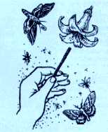
I discovered it with a drawing coal-a burnt twig-by passing it over large, bell-shaped flowers (tulips, lilies, amaryllises, mallows, pumpkins).

Already at a distance I could feel a "braking", as it were, of this detector. Soon I was able to find a flower in a dark room standing one or two meters away from it-but only if it had not been moved, because a "false target" would be left in its old place-the "residual phantom" I already mentioned.

I do not possess any supersensory abilities, and any person after some training would be able to do the same. Instead of coal one could use a 10-cm-long piece of a yellow sorghum stem, or a short pencil whose rear end should be facing the flower.

Some people would be able to feel the flower (a "warm", "cold", or "shivering" sensation emanating from it) with their bare hands, tongues, or even faces. As many experiments demonstrated, children and adolescents are particularly sensitive to Waves of Matter.

As for bees that nest underground, their "knowledge" of the CSE is vital for them first of all, because it enables the builder of a new gallery to stay away from a neighboring nest. Otherwise the entire bee-city cut through with intersecting holes would simply collapse.

Secondly, plant roots cannot be allowed to grow down into the galleries and honeycombs. Thus roots stop a few centimeters away from the honeycomb, or else, feeling that nests are near, they start growing aside.

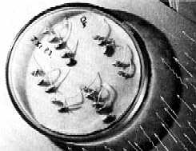
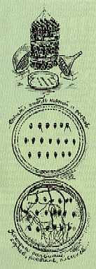
The latter conclusion was confirmed by my many experiments on sprouting wheat seeds in a strong CSE field, as compared to seeds germinating in the same climatic conditions but in the absence of the CSE.

Photographs and drawings show both the dying of roots in the experimental batch and their sharp deviation in a direction away from my "artificial honeycomb".

Thus bees and weeds back at the lake had long ago made a pact - another example of the highest ecological expediency of all Being. And in that same spot on the globe we see yet another example of people's mercilessly ignorant attitude to Nature...

The bee-city is now gone; every spring thick streams of fertile black earth soil run down, between filthy heaps of trash, to the lifeless, salty puddles that not too long ago were a string of lakes with countless flocks of sandpipers and ducks, white swans, and hovering fish-hawks. And by the steppe thinned out by bee holes, one used to hear the hum of hundreds of thousands of bees that for the first time led me into the Unknown.

I must have tired the reader with all these honeycombs of mine... A separate thick book would be required to describe all my experiments. Therefore I will only mention one thing: my pocket, battery-powered calculator often malfunctioned in the CSE field: it either erred, or sometimes its display window would fail to light up for hours. I used the field of a wasp nest combined with that of my two palms. None of these structures had any effect in isolation.

I will also note that hands with their tubular phalanxes, joints, ligaments, blood vessels, and nails are intensive CSE emanators capable of giving a powerful push to the straw or coal indicator of my little instrument from a couple of meters' distance. Practically anyone could do it. This is why I am convinced that there are no people with supersensory abilities, or rather that all the people have them... And the number of those who from a distance can move lightweight objects on a table, hold them suspended in the air or "magnetically" attached to the hand is far greater than is usually thought. Try it yourself! I look forward to your letters.

There once was an ancient folk game: one man sits on a chair, and over his head, four of his friends "build" a grid of horizontally stretched palms with slightly spread fingers-first right hands, then left, with 2 cm gaps between them. In 10-15 seconds, all four synchronously put their pressed-together index and middle fingers under the armpits and under the knees of the sitting man, and then they energetically toss him up in the air. The time between "collapsing" the grid and tossing the man must not exceed two seconds; the synchronicity is also very important. If everything is done right, a 100-kilo man flies up almost to the ceiling, while the ones who tossed him claim he was light as a feather.

A strict reader may ask me how it is possible. Doesn't it all contradict laws of nature? And if so, am I not propagating mysticism? Nothing of the sort! There is no mysticism, the thing is simply that we, humans, still know little of the Universe which, as we see, not always "accepts" our, all too human rules, assumptions, and orders... Once it dawned on me: the results of my experiments with insect nests bear too much similarity to the reports of people who happened to be in the vicinity of... UFOs. Think and compare: temporary malfunctioning of electronic devices, disrupted clocks-i.e., time, an invisible, resilient "obstacle", a temporary drop in the weight of objects, the sensation of a drop in human weight, phosphenes-moving, colored flashes in the eyes, a "galvanic" taste in the mouth...

I am sure you have read about all this in UFO journals. I am now telling you it can all be experienced in our Museum. Come visit! Was I standing on the threshold of yet another mystery? Quite so. And again I was helped by chance, or rather by my old insect friends. And again there were sleepless nights, failures, doubts, breakdowns... even accidents... And I had no one to turn to for advice-they would have just laughed, or worse...

But I can say this, my reader: he is happy who has a more or less adequate use of his eyes, head, and hands-skillful hands are particularly important!-and trust me, the joy of creative work, even of work that ends in failure, is far higher and brighter than earning any diplomas, medals, or patents.

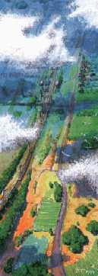

Flying an Anti-gravitational Platform
(excerpts from a diary)

Judge it for yourself from my diary excerpts-obviously simplified and adapted for this book. Pictures and drawings will help you to evaluate my story... A hot summer day. Far-away expanses drown in a bluish-lilac haze; the sky's gigantic cupola with fluffy clouds stretches above the fields and coppices. I am flying about 300 meters above ground, with a distant lake-a light, elongated spot in the haze-as my reference point.

Blue, intricate tree contours slowly recede; between them, there are fields. Those, bluish-green ones are fields of oats; the whitish rectangles with a strange, rhythmic twinkling are those of buckwheat. Straight ahead of me is a field of alfalfa-its green color is familiar, it resembles the oil paint "cobalt medium-green". Green oceans of wheat on the right are of a denser shade and resemble the "chrome oxide" paint. An enormous, multi-colored palette floats further and further backwards.

Footpaths meander between fields and coppices. They join gravel roads which it turn stretch further out, toward the highway, still invisible from here for the haze, but I know that if I flew on the right side of the lake, I would see it-a smooth, gray strip without a beginning or an end, on which cars-small boxes-are slowly crawling.

Isometric, flat shadows of cumulus clouds are picturesquely spread around the sunny forest-steppe. They are deep blue where they cover coppices, and are various shades of light blue over fields. Now I am in the shadow of one such cloud: I accelerate-it's quite easy for me to do that-and leave the shadow.

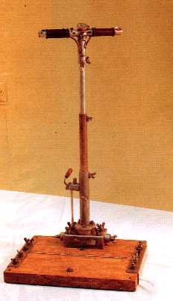
I lean forward slightly and feel a warm, taut wind coming far down below, from the sun-warmed ground and plants. It comes not from the side, as on the ground, but strangely from the surface up. I physically feel a thick, dense current with a strong odor of blooming buckwheat. Of course this jet can easily lift up even a large bird-an eagle, a stork, or a crane-if it freezes its spread wings. But I have no wings and am suspended in the air not by the upward jet.

In my flight I am supported by a flat, rectangular little platform, slightly bigger than the seat of a chair, with a pole and two handles to which I hold on and with whose help I navigate the device. Is this science fiction? I wouldn't say so...

In a word, the interrupted manuscript of this book was abandoned for two years because generous, ancient Nature, again through my insect friends had given me another Something-and it did so, as usual, elegantly and inconspicuously, yet swiftly and convincingly. And for two years the Discovery did not let me go, even though it seemed to me I was mastering it at a break-neck speed.

(Note: Grebennikov would have been approximately 62-63 years of age in 1990-1992)

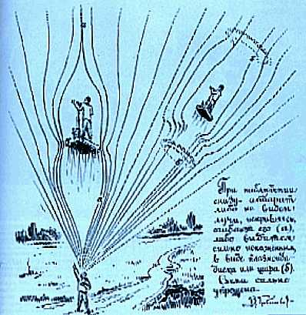
But it always happens this way: when your work is new and interesting, time flies twice as fast. A light spot of a steppe lake is already much closer. Beyond it, the highway is visible with already distinctly discernable boxes of cars. The highway is about 8km away from the railway that runs parallel to it, and if I look closer, I can see the poles of the power line and the light-colored embankment of the railway. It is time to turn some 20 degrees to the left.

I am not seen from the ground, and not just because of the distance: even in a very low flight I cast almost no shadow. Yet, as I found out later, people sometimes see something where I am in the sky-either a light sphere, a disk, or something like a slanted cloud with sharp edges that moves, according to them, not exactly the way a cloud would.

One person observed a "flat, non-transparent square, about one hectare in size"-could it have been the optically enlarged little platform of my device?

Most people see nothing at all, and I am for the moment pleased with it-I can't be too careful! Besides, I still haven't determined what my visibility or invisibility depends on.

Therefore I confess that I consciously avoid people in my flight and for that purpose bypass cities and towns, and even cross roads and footpaths at high speed, after making sure there is no one on them.

In these excursions-no doubt, fictional for the reader, but for me already almost casual-I trust only my insect friends depicted on these pages.

The first practical use of my discovery was-and still is-entomological: to examine my secret places, to take a picture of them from above, to find new, still unexamined Insect Lands in need of protection and rescue. Alas, Nature established its own, strict limitations on my work: just as on a passenger plane, I could see but couldn't photograph.

My camera shutter wouldn't close, and both rolls of films I had taken with me-one in the camera, the other in my pocket-got light-struck. I didn't succeed in sketching the landscape either; as both my hands were almost always busy, I could only free one hand for a couple of seconds. Thus I could only draw from memory. I managed to do that only immediately after landing-though I am an artist, my visual memory is not that great.

In my flight I did not feel the same way we do when we fly in our sleep.

It was with flying in my sleep that I started this book a while ago. And flying is not so much pleasure as it is work, sometimes very hard and dangerous. One has to stand, not hover, the hands are always busy, and a few centimeters away there is a border separating "this" space from "that", on the outside.

The border is invisible but very treacherous. My contraption is still rather clumsy and resembles perhaps... hospital scales. But this is only the beginning!

By the way, besides the camera, I sometimes had trouble with my watch and possibly, with the calendar too: descending on a familiar glade, I would occasionally find it slightly "out of season", with a two-week deviation, and I had nothing to check it against.

Thus it is possible to fly not just in space but also-or so it seems-in time as well. I cannot make the latter claim with a 100% guarantee, except perhaps that in flight, particularly at its beginning, a watch runs too slow and then too fast, but at the end of the excursion starts running accurately again.

This is why I stay away from people during my journeys: if time is involved alongside gravitation, I might perhaps accidentally disrupt cause-and-effect relations and someone might get hurt.
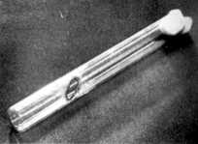
This is where my fears were coming from: insects captured "there" disappear from test tubes, boxes, and other receptacles.

They disappear mostly without a trace. Once a test tube in my pocket was crushed to tiny bits, another time there was an oval hole in the glass, with brown, as though "chitin" edges-you can see it in the picture.

Many times I felt a kind of burning or an electric shock inside my pocket-perhaps at the moment of my prisoner's "disappearance".

Only once did I find a captured insect in the test tube, but it wasn't the adult ichneumon with white rings on its feelers, but its... chrysalis, i.e. its earlier stage. It was alive-it moved its belly when touched. Much to my dismay, it died a week later.

It is best to fly on clear summer days. Flying is much more difficult when it rains, and almost impossible in winter-not because of the cold. I could have adapted my device accordingly, but since I am an entomologist, I simply do not need winter flights.

How and why did I come to this discovery? In the summer of 1988, as I was examining under a microscope the chitin shells of insects, their pinnate (feathery) feelers, and the thinnest structure of butterflies' wings, I got interested in an amazingly rhythmical microstructure of one large insect detail.

It was an extremely well ordered composition, as though pressed on a complex machine according to special blueprints and calculations. As I saw it, the intricate sponginess was clearly not necessary either for the durability of the detail, or for its decoration. I had never observed anything like this unusual micro-ornament either in nature, in technology, or in art.

Because its structure is three-dimensional, so far I have been unable to capture it in a drawing, or a photograph. Why does an insect need it? Besides, other than in flight, this structure at the bottom of the wing case is always hidden from the eye-no one would ever see it properly. Was it perhaps the wave beacon with "my" multiple cavernous structures effect? That truly lucky summer there were very many insects of this species, and I would capture them at night: neither before, nor after was I able to observe these insects.

I put the small, concave chitin plate on the microscope shelf in order again to examine under strong magnification its strangely star-shaped cells. I again admired this masterpiece of nature, and almost purposelessly placed it on top of another, identical plate that had the same unusual cells on one of its sides.

But no! -the detail broke loose from my tweezers; for a few seconds it hung suspended above the other plate on the microscope shelf, turned a few degrees clockwise, slid to the right, turned counterclockwise, swung, and only then abruptly fell on the desk.

You can imagine what I felt at that moment... When I came to my senses, I tied a few panels with a wire-it wasn't an easy thing to do, and I only succeeded when I positioned them vertically. What I got was a multi-layered chitin block. I put it on the desk.

Even a relatively large object-such as a paper tack-could not fall on it-something pushed it up and aside. When I attached the tack on top of the "block", I witnessed such incredible, impossible things (for example, the tack for a few moments was lost from sight) that I realized it was no beacon, but something else entirely.

And again I got so excited that all the objects around me became foggy and shaky. It was with a huge effort that I managed to pull myself together in a couple of hours and continue working.

So, this is how it started. Of course, much still remains to be understood, verified, and tested. I will certainly tell my readers about the finer details of my machine, about its propulsion principles, about distances, heights, speeds, equipment, and all the rest-but in my next book.

...I conducted my first, very unsuccessful and highly dangerous flight on the night of March 17, 1990. I didn't have the patience to wait till the warm season and neglected to go to a deserted area. I already knew that night was the most dangerous time for this kind of work.

I had bad luck from the very beginning: the panel blocks of the right part of the bearing platform periodically got stuck. I should have fixed the problem immediately, but neglected to do so. I took off right in the middle of the Agricultural Academy campus, erroneously assuming that at 1 AM everyone was asleep, and nobody would see me.

The lift-off went well, but in a few seconds, when the lit windows of buildings sank beneath me, I felt dizzy. I should have landed right then but remained airborne, which was wrong because a powerful force snatched away my control over the movement and weight, and it pulled me in the direction of the city.

Drawn by this unexpected, uncontrollable power, I crossed the second circle of nine-story buildings in the city's residential area (they are laid out in two huge circles with five-story buildings, including ours, inside them), then I crossed a snow-covered, narrow field, and the Academy City highway... The dark immensity of Novosibirsk was closing in upon me, and it was closing in fast. I was already near a bunch of tall factory chimneys many of which fumed thick smoke-night shift was on. I had to do something quickly.

I got on top of the situation only with a great effort. Finally I managed to conduct an emergency adjustment of the panel blocks. My horizontal movement slowed down, but then I again felt sick.

Only at fourth try did I succeed in stopping the horizontal movement, at which point my platform was hanging over Zatulinka, the city's industrial district. The sinister chimneys silently continued to fume right underneath me.

I rested for a few minutes-if one could call hanging over a lighted factory fence rest-and after I made sure the "evil power" has passed, I glided back-yet not in the direction of our Agricultural Academy campus but to the right from it, toward the airport. I did this to foul the trail, in case someone had seen me.

Only about halfway to the airport, over some dark, night fields where there was clearly no one around, I abruptly turned home... Next day I naturally couldn't get out of bed.

News on TV and in newspapers was more than alarming. Headlines, such as "UFO over Zatulinka" and "Aliens again?" meant that my flight had been detected. But how! Some perceived the "phenomenon" as glowing spheres or disks-many actually saw not one sphere but two! Others claimed they had seen a "real saucer" with windows and rays.

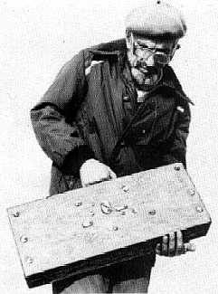
I am not discounting the possibility that some Zatulino residents saw not my near-emergency evolutions, but something else entirely that had nothing to do with those. Besides, March of 1990 was particularly rich in UFO sightings in Siberia, near Nalchik, and especially in Belgium where, according to Pravda, on March 31 the engineer Marcel Alferlane took a two-minute film of the flight of a huge triangular craft which, according to Belgian scientists, were none other than "material objects with a capacity no civilization can currently create."

Is it really so? As for me, I would suggest that the gravitational filter platforms (or as I call them, panel blocks) of these machines were in fact small, triangular, and made here on Earth-but with more sophistication than my half-wooden contraption.

I too wanted to make the platform triangular-it is much safer and more efficient that way-but I chose a rectangular design because it is easier to fold, and when folded, it resembles a suitcase, a painter's case, or a briefcase that can be thus disguised so as not to arouse suspicion. I, naturally, disguised it as a painter's case.

I had nothing to do with the sightings in Nalchik or Belgium. Besides, as it may appear, I am very impractical in the use of my discovery-I only fly to my entomological preserves. These are far more important to me than any technological finds.

At the moment, I have eleven such preserves: eight in Omsk region, one in Voronezh region, and one near Novosibirsk. There used to be six of them in Novosibirsk region, all of them created, or rather salvaged by my family, and me but they don't like them here. Neither the Agricultural Academy (still more obsessed with "chemistry" than with anything else), nor the Environmental Protection Committee were willing to help me salvage these little preserves from evil, ignorant people.

Thus I am continuing my journey westward under the magnificent, fluffy clouds at noon. The blue shadows of the clouds, the intricately shaped coppices, and the multicolored rectangles of fields float backwards below me.

The speed of my flight is quite high, but there is no wind in my ears-the platform's force field has "carved out" from space an upward-diverging, invisible column that cuts the platform off the earth's gravitational pull. But it left me and the air inside the column - intact. I think that all this, as it were, parts space in flight, and then closes it behind me.

This must be the reason for the invisibility, or the distorted visibility, of the device and its "rider"-as was the case with my flight over Novosibirsk's Zatulinka suburb.

But the protection from gravity is regulated, even though it is incomplete: if you move your head forward, you already feel the turbulence of the wind that clearly smells either of sweet clover, of buckwheat, or of the colored weeds of Siberian meadows.

I leave Isilkul with its huge grain elevator on my right and gradually begin to descend over the highway, making sure that I am invisible to drivers, passengers, and people working in the field.

My platform and I cast no shadow (although the shadow occasionally appears): I see three kids on the edge of a forest, go down, drop my speed, and fly right near them. They show no reaction, which means that everything is fine.. neither I, nor my shadow is visible. Or heard: the propulsion principle of my device is such that the platform makes no sound whatsoever, because there is practically no air friction.

My journey was long-at least forty minutes from Novosibirsk. My hands are tired as I can't take them off the controls, so are my legs and body-I have to stand up straight, tied to the vertical pole with a belt. And even though I can travel faster, I am still afraid to do so-my hand-made machine is still too small and fragile.
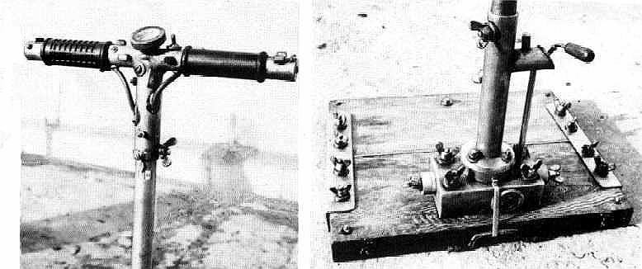
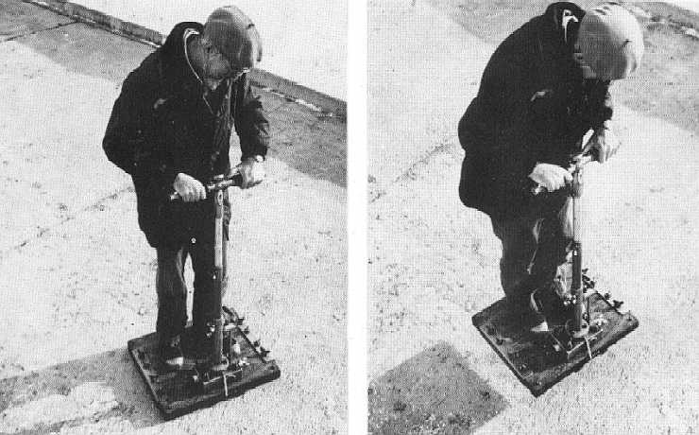

]

I again go up and ahead, and soon I see the familiar landmarks-a road intersection, a passenger terminal on the right side of the highway. Another five kilometers, and finally I see orange columns of the Preserve fence. The Preserve is this year-come to think of it-twenty years old! How many times I saved this child of mine from trouble and bureaucrats, from chemicals-loaded aircraft, from fires, and many other evil deeds. And the Land of Insects is alive and well!

Descending and braking, which is done by cross-shifting filter blinds under the platform board, I already see the thicket of carrot weed, make out the light heads of their flowers resembling azure balls-they are of course covered with insects, and an incredible joy comes over me, taking away my fatigue, for it was I who saved this piece of Earth, even if a small one, less than seven hectares.

Already for twenty years no one has driven here, no one has cut the grass, tended cattle, and the soil has risen in places to fourteen centimeters high. Not only several locally extinct species of insects have returned, but also such weeds as feather grass of rare varieties, purple Scorzonera whose large flowers in the morning smell of chocolate, and many other plants. I feel the thick smell of cuckoo flower-only this Middle Glade smells like that, it is right behind the fence of the preserve, and fills me with yet again with the joyful anticipation of another encounter with the World of Insects.

Here they are, I can see them very well even from ten meters above the ground on the wide umbrellas and azure balls of angelica and carrot plants: dark orange butterflies sit on them in groups; heavy hornets bow the white and yellow inflorescences of lady's bedstraws; ginger and blue dragonflies with trembling wide wings and a fine network of veins hover next to my head. I slow down even more, and see a sudden flash below: my shadow, hitherto invisible, has finally appeared and now slowly glides along weeds and bushes.

But I am already safe-there is not a soul around, and the highway three hundred meters north of the preserve is now empty. I can land. The stems of the tallest weeds rustle against the bottom of my "podium"-the platform with the panel blocks.

But before putting it down on a little bump, I, in a fit of joy, again spread the blinds with my control handle, and vertically go up. The landscape below quickly shrinks - shrivels as it were: the shrubs of the preserve, its edges and fences, all the surrounding coppices and fields. The horizon begins to curve on all sides in a huge groove, opening up the railroad that runs two kilometers on the left, then a village on the right-it twinkles with its light slate roofs.

Further on the right is Roslavka, the central estate of Lesnoy State Farm-it already looks like a small city. Left from the railroad are cow farms of Lesnoy's Komsomolsk branch; they are surrounded by a yellow ring of straw and dry - foot worn manure. In the far west, where the smooth curve of the railroad disappears (this is actually confusing: the railway is straight as an arrow), there are small houses and the neat white cube of the Yunino railroad terminal, six km away.
Beyond Yunino, there are limitless expanses of Kazakhstan drowning in the hot, bluish haze.

And finally here it is, below me... Isilkulia, the land of my youth; it's very different from how it appears on maps and plans with their inscriptions and signs. It is vast, limitless, alive, interspersed with dark, intricate islands of coppices, cloudy shadows, light, clear spots of lakes.

The huge disk of the Earth with all this for some reason appears more and more concave-I still haven't discovered the reason for this already familiar illusion. I go up higher, the rare, white cloud masses sink lower, and the sky is darker than below-it is dark blue. The fields visible between the clouds are already covered with a thickening blue haze, and it is more and more difficult to make them out. Too bad I can't take my four-year-old grandson Andrei with me; the platform could easily lift us both. Yet one can't be too careful...

... Goodness, what am I doing? I cast a shadow back on the Glade, didn't I? This means I can be seen by thousands, as on that memorable night in March. It is day now, and I may again appear as a disk, square, or worse, my own person... There is also a cargo plane, still soundless, coming straight at me, quickly growing in size; I already see the cold shimmer of its body and the pulsation of its unnaturally red blinker.

Down, quick! I brake abruptly, make a turn; the sun is at my back; my shadow should be across from me, on the gigantic, convex wall of a white cloud. But there is none, only a multicolored glory; an iridescent, bright ring familiar to all pilots has brushed the cloud ahead of me.

I sigh with relief-this means nobody saw either me, or my "double" in the guise of a triangle, square, or a "banal" saucer... A thought occurs to me (I must say that despite the desperate technical and physical inconvenience, imagination works much better and faster in a "falling" flight): what if I am not the only one out of five billion people to have made my discovery; what if flying devices based on the same principle-both home-made and professional-have long been constructed and tested?

But all screening platforms have the same quality: sometimes they become visible to other people; pilots too are "transformed"-they are seen as "humanoids" in silver costumes, either short and green, or flat as if made of cardboard (Voronezh, 1989), etc. Thus it may very well be that these are not alien UFO crewmen, but "temporarily deformed"-of course to outside observers-earthly pilots and builders of little platforms, such as mine, who have made their inventions reliable.

My advice to those who in their study of insects comes across the same phenomenon and begin making and testing a "gravitoplane" (by the way, I am convinced that one can't make the discovery without insects) is this: to fly only on fine summer days, to avoid working in thunderstorms or rain, not to get too far or too high, not take a thing with you from the landing area, to make all assembly units maximally strong, and to avoid testing the device in the vicinity of any power lines, towns (let alone cities), transport, or people.

The best site for testing is a distant forest glade, as far away from human habitation as possible; otherwise a phenomenon known as poltergeist could occur in the radius of a few dozen meters-"unexplained" movements of household objects, switching off, or on, of household electric appliances, and even fires.

I myself have no explanation for all this, but it seems that these phenomena are the consequence of temporal disruptions, a complicated and treacherous thing. Not a single, even tiniest fragment or particle should be dropped either during the flight, or in the landing area.

Let us remember the Dalnegorsk phenomenon of January 29, 1986-apparently a tragic one for the inventors, when the entire device was blown apart and scattered on a vast area, and only small shreds of filter cells were found, impossible to analyze chemically (as it should be!).

Remember, I wrote that insects taken "there" and moved "here" in a test tube disappeared, and a hole was formed in the tube, if it remained intact.

It turns out these holes resembled those in window glass; the latter sometimes appear in residential and office buildings, occasionally in "bursts" in the windows of several rooms and floors. A hole is 3-5 mm on the outside, widening in a cone to he inside, with exit diameter of 6-15 mm. Some holes are melted or colored in brown on edges-just as it happened in the case of my insect in a test tube.

It seems that this type of poltergeist is caused not, as I used to believe, by short-lived microplasmoids of a tiny ball lightening type, but by particles and specks carelessly dropped while testing a device similar to mine. The photographs of window holes on these pages are documentary and made by me at the scientific center of the Agricultural Academy near Novosibirsk. I can show them to anyone who wants to see them. These holes appeared during 1975-1990, but none of them, except perhaps the very last one, are related to my flights.

I am certain that part of UFO descriptions are actually those of platforms, panel blocks and other large parts of devices deliberately or accidentally taken out of the active field by their designers and makers. These fragments are capable of causing much trouble to others, or at best, to generate a series of improbable tales and stories in papers and magazines, often accompanied by "scientific" commentary...

Why am I not disclosing the particulars of my discovery at this time? Firstly, because one needs time and energy for proving the truth. I have neither. I know how daunting this task is from my own bitter experience of trying to get recognition for my previous discoveries, including such an obvious one as the Cavernous Structures Effect of whose reality you, my readers, I am sure, are by now convinced.

This was the result of my protracted, painstaking efforts to get the CSE scientifically recognized:
"Any further correspondence with you on the subject of your patent application is counterproductive."

I know personally some of the High Priests of Science, and I am certain that were I ever to get an audience with one such person (which is now practically impossible), were I ever to;

- open my painter's case,
- attach the pole,
- turn the handle,
- and soar to the ceiling,

…he wouldn't be a bit impressed-or worse still, would order the trickster out of the office. I look forward to times when young people will replace these "priests".

The second reason for my "non-disclosure" is more objective. I found these antigravitational structures only in one species of Siberian insects. I am not even naming the class to which this insect belongs-it seems to be on the verge of extinction, and the population surge I registered back then was possibly local and final.

Thus, if I were to name the genus and the species, what is the guarantee that dishonest people, halfway competent in biology, would not rush out to ravines, meadows, and forests to catch perhaps the very last samples of this Miracle of Nature?

What are the guarantees that they would not plough up hundreds of glades, cut down dozens of forests to get to this potentially lucrative prey? Therefore, let all I have related in this chapter and in the addendum remain science fiction; may Nature herself never reveal this secret to them-it would take a lot of effort, and they would never be able to get it by force as there are still several million insect species living on the planet.

Spend at least an hour on the morphological study of each of them, then calculate the odds of encountering the Unusual, and I will sincerely wish you diligence and a very long life, for even if you took no days off, working eight hours a day, you would need a thousand years of life.

I hope I will be understood and forgiven by those of my readers who wanted immediate information about my discovery not for selfish ends, but simply out of curiosity. Indeed, what would you do in my place if you were to act in the best interests of Living Nature?

Besides, I can see that similar inventions have been made by other people who are also in no rush to take their discoveries to bureaucrats' offices, preferring to fly across night skies in the guise of strange disks, triangles, or squares with chatoyant (iridescent) glimmer.

Falling down, or rather sinking down... I orient myself and look to see if there is anyone around. I brake abruptly about forty meters from the ground, and land safely where I always do-on a tiny glade in the Big Forest of the preserve. You won't find it on a map, and if you get there, you won't be able to find it either.

Don't judge me for the fact that the branches of several aspens there are cut or sliced "by lightening": The strictly vertical take-off and landing are very difficult, and the initial trajectory is for the most part slanted, particularly at take-off, when the platform is for some reason carried off away from the sun, and sometimes the other way around.

I loosen the screws on the control pole, then shorten it like an antenna of a portable radio, and remove it from the platform which I fold in half. Now it looks like a painter's case, a box for paints, if only a bit thicker. I put the case, some food, and a few tools for repairing the fence in my backpack and make my way for the Middle Glade between aspens and short dog-rose bushes. Even before I leave the forest, I see a good omen-a family of fire-red toadstools that have lined up on the forest bedding in a wide curve, or, as it used to be called in folklore, a "witch's ring".

Why "witch's"? And in general, why does one have to break, knock off, or trample this beautiful mushroom of Siberian forests? I often asked mushroom-pickers why they do it. The answer was, "because it's inedible!" But turf, clay, twigs, tree stumps, and stones are inedible too.

If there were rocks lying in the forest instead of mushrooms, no one would be knocking them off. It seems that inedible mushrooms are knocked off because they are alive; they are knocked off only in order to kill them! What is this then?

Do people really have this in their blood-to knock off a mushroom, to crush a bug, to shoot a bird, a hare, or a bison? And is this not where boorishness, sadism, pogroms, and wars originate? One really wants not to believe it, but I put myself in the shoes of an alien: I come to Earth to visit humans and see them knock off mushrooms, crush insects, shoot birds and each other.

What would I do? I would immediately turn my spacecraft around and go back. I wouldn't return for at least 500 earth years... What would you do, my reader, if you were an alien?

It's a good thing at least that this little family of toadstools is hidden from evil eyes and cruel feet. Every summer it gives me joy to see its special life, its cinnabar-red, moist caps with large, whitish scales. But here is the Glade. I step on it, as usual, with my heart sinking with a constant longing for this dear, faraway nature of Isilkul, with a fear that some "master" might decide to plough it up, and with a joy that it is still unploughed, uncut, and untrampled...

And it really means nothing that in my backpack I have a folded, i.e. neutralized platform with gravitational, micro-cellular filter blocks, and between them, a folded pole with field regulators and a belt with which I fasten myself to the pole.

What difference does it make that I got about fifty years ahead of contemporary science with my discovery? People are still going to master this and many other mysteries of Matter, Space, Gravitation, and Time.

But no super civilization on any planet of any super galaxy is going to re-create this very Glade with its complex, fragile, trembling Life, with its lady's bedstraws, meadowsweets, and feather grass...

Where else, in what corner of the Universe are you going to find a match for this lilac-blue bellflower in whose semi-transparent entrails two flower flies are doing their love dance? On what other planet would a nearly tame blue butterfly land on your outstretched hand to have a taste of something salty-sausage, cheese, or a pickle? Or else, just to walk up and down your palm, opening and closing its gray wings on whose backside there is a fine ornament of round eye-shaped spots?

...It hasn't been too long since we, humans, started flying-first air balloons, then airplanes, and now powerful rockets that we send to other heavenly bodies. What next? Next we are going to fly to other stars at a speed close to that of light; but even the closest galaxy would still be out of reach.

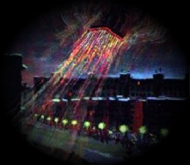
Yet Humankind-if it earns the name of Intelligent-will solve many riddles of the Universe and will then overcome that hurdle too. Then any worlds of the Universe will become accessible, close... even if they are trillions of light years away. It'll happen, for it is all a matter of Reason, Science, and technology. But of nothing else. Only this Glade may disappear if I-and there is no one else to rely on-am not going to preserve it for my close and distant descendants.

So what is more valuable to Humanity at this time-the insect preserve or the home-made device capable of developing the zenithal pull of at least 100 kg and the horizontal speed of 30-40 km/min? I am asking you, my reader. But think hard before you give a serious, responsible answer.

Look at these pictures. This is my rather simple device in assembly. A flexible cable inside a steering column transmits movement from the left handle to the gravitational blinds.

By joining or parting these "wing cases", I lift off or land. Once I lost the left handle in a free-falling descent and would have been in a better world if the platform hadn't dug out a rather deep well in the tillage-first a vertical one, then a horizontal, facing away from the sun.

Thus I not only survived, but also felt almost no impact-just darkness. I extracted myself and my fairly badly damaged device from this well, but not without efforts, as the "well" had no slag heaps!

I had to use all my ingenuity to disguise it. If seen from the road, it would have caused much speculation, and may even have led some over-zealous investigators to the culprit. Similar wells-also with a side-tunnel and without slag heaps-were suddenly formed on October 24, 1989 in the fields of Khvorostyansk
District of Samara Region. Komsomol'skaya Pravda described it in detail on December 6 of the same year. It seems I am not alone. And quite likely am "inventing a bicycle". Well, actually the top part of my device looks very much like one: the right handle is used for horizontal, onward march achieved, also via a cable, by the incline of both groups of "wing case" blinds. I never fly faster than 25 km/min, preferring to go ten times slower.

...I don't know whether I have persuaded you, my reader, that similar devices will soon be available to practically everyone, while Living Nature which humans cannot survive without won't be available to anyone if we don't save it.

But I don't want to seem entirely greedy and will give researchers another Patent of Nature, one also related to Movement and Gravitation. Physicists say that an unsupported mover is impossible. In other words, a device completely isolated from the environment won't fly or drive-a car won't go without outer wheels, a plane won't fly with a covered propeller or engine, neither will a rocket with stopped nozzles. Baron Münchhausen who managed to pull himself up by the hair from a muck-mire is the only exception.

It happened near Novosibirsk in 1981 when we were studying the entomo-fauna of alfalfa - its pollinators and pests. Walking along the field, I was "mowing" alfalfa with an insect net and was then moving its contents-insects, leaves and flowers-into a glass jar. Such is the cruel method of studying the insect make-up of fields... no better one has been invented. Alas, such was the work with which I earned my living at the Institute of Agricultural Chemistry. I was about to throw a piece of ethered cotton wool into the jar and then cap it, when a light little cocoon jumped up at me.

It was oval-shaped, rather dense and non-transparent. One of the "prisoners" of the jar must have pushed it-cocoons can't jump on their own! But the cocoon proved me wrong: it jumped up one more time, hit the glass wall, and fell down. I took it out and put it in a separate test tube. At home I looked at it through a binocular microscope-nothing special, a cocoon like any other, about 3 mm long, 1.5 mm wide. Its walls felt strong to the touch-as they should. The cocoon energetically jumped when lit-or warmed?-by the sun; it was quiet in the dark. It could jump 30mm longwise and, what was even more remarkable, up to 50mm high. As far as I could tell, it flew smoothly, almost without tumbling. No doubt, the larva of the insect was responsible for the movement. But it was impossible to see how it was happening.

Jumping ahead, I can tell you that the cocoon finally produced a male insect of the ichneumon family, the Batiplectes anurus species. It is beneficial for agriculture because its larvae parasitize, the weevil, is a pest of alfalfa.

The flying cocoon was finally to land in a cool place-for example, a crack in the ground. It must have found myself in my net during its strange journey, i.e. at the moment of its jump. It all resembled poltergeist-unexplained "jumps" of household objects, many times described in papers. I would put it on glass and look at it from below: could it be that the larva draws in its bottom and then abruptly releases it? Nothing of the kind - there were no dents at any point - and the cocoon jumped no matter how I rolled it. It was also remarkable that from horizontal, slippery glass it jumped sideways.

I measured its trajectories: they were up to 35 cm long and up to 50 mm high, that is, the cocoon lifted itself up to a height 30 times its own width! Shall I leave this capsule without support? But how? With a piece of loose cotton wool! I loosen a piece of cotton wool by pulling it a little, place the cocoon on this "cloud", put it out in the sun and impatiently wait. If the cocoon's inhabitant jumps by hitting the lower wall, making the cocoon to bounce off its support, this time it won't work because the impact will be absorbed by the thin, paddy fibrils of the cotton wool. Theoretically, the cocoon shouldn't even move. But no: it takes off from its motionless pad-up and aside, as it did before.

I measure the broad jump: 42 mm, i.e. as before. The insect must have been hitting not the bottom, but the top part of the cocoon-at any rate, it must have been doing something that caused the capsule to move.

Frankly speaking, it is as I, while now writing these notes, that I feel agitation; back then, in 1981, I found nothing supernatural in the jumps of my prisoner. This was because I knew that, according to physics, there are and there can be no unsupported movers. Otherwise I would have bred a couple of hundred of those insects-thankfully, they were quite common-and would have studied the phenomenon thoroughly.

Now let us fantasize a little: what if the batiplectes wanted to leave the Earth? An adult, winged insect would have no luck-our atmosphere is quite rarefied at the top... wings are no match for it. A larva in a cocoon is an entirely different matter. It could, in theory, after lifting its capsule 5 cm in a jump, take it up even further while in the air, then again and again...

And if the cocoon were airtight-I mean the air reserve for the pilot's breathing-then the device would be able to leave the atmosphere and would have no obstacles to a limitless build-up of speed. Such is the alluring, incredible value of unsupported movers, declared, alas, a product of empty fantasy. But even if you are no physicist, you still have a hard time imagining what a tiny larva does in there if its vessel soars 5 cm high. It simply can't be-and yet it jumps!

Physicists say that this is "beyond science" as it "contradicts the laws of nature." The only problem is that the Batiplectes anurus doesn't know it. The physicists' ban must also have been unknown to the leading, experienced biologists who honestly wrote the following on page 26 of the academic Register of Insects of European USSR (vol. III, pt. 3): "the cocoon jumps up as a result of abrupt movements of the larva inside the cocoon." In a word, it is a working-and tested-example of a safe, unsupported mover. I am giving it to you, my reader: invent, design, build, and Godspeed! But hurry!

Massive chemical warfare has been waged against the alfalfa pest snout-beetle (phitonomus). Humanity may actually win it. But the price may be too great: with the destruction of the Phitonomus varnabilis beetle, our planet's fauna may also lose the ichneumon Batiplectes anurus as it parasitizes only this kind of weevil and cannot survive without it.

Meanwhile, any proposals on using biological weapons against the pest-such as our very ichneumon and other insect predators are completely rejected by the bosses of Russian agriculture and agricultural science. I have been fighting them on this for years, but so far with little success.

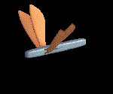
However, one could understand those in charge too-how can one stop expensive chemical factories? And why do agrarian scientists care about some unsupported mover that doesn't allow alfalfa to be treated with poison? Hurry up, biologists, engineers, physicists! For if Chemistry wins, this Mystery-and with, a host of other Mysteries related to it-will leave people forever. Without insects, people won't invent it themselves. Please trust me, an entomologist with 60-year experience.

At the end of my first book, A Million Riddles, published in Novosibirsk in 1968, there is a drawing that I am reproducing again: a man is flying over Novosibirsk's Academic City. He is flying a device based on a huge pair of insect wings.

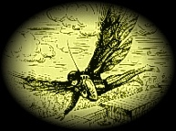
At the time I dreamed of inventing such a machine. Strangely, the dream came true precisely because of my friendship with insects-yet not by blindly copying the most noticeable parts-for example wings that only make me smile now-but through careful study of living Nature.

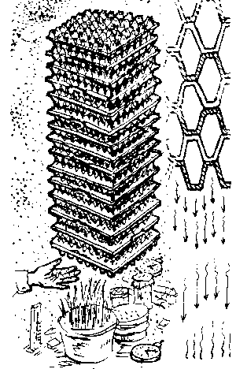
Nothing would have been possible without my six-legged friends. No one would be able to do without them either. Thus, safeguard their world, the ancient, wonderful world of Insect... for it is an infinite, unique treasure of Nature's mysteries! I beg you all, take care of it!

FROM THE NOTEBOOK OF A NATURALIST
Artificial honeycomb.

Take a dozen and a half papier-mâché supermarket egg cases (30-egg variety), tie them up or glue them together (one on top of another) in such a way as to join the "teeth" to one another, not to the hollow spots.

You will have large cells, similar to multi-cellular combs of a certain "paper" wasp, except many times larger. Fix the whole set (it can be enclosed in a case) over the head of a person sitting in a chair, with the bottom "comb" is 10-20 cm above the head.

Leave the person there for 10-15 min. The "unnatural", unusual transformation of the spatial shape formed by the set can be picked up even by the palm of a hand.

Experiment with couching seeds, or breeding microorganisms and insects under a "macrocomb" and compare the results with those of identical experiments conducted at least 2 m away from the comb. Repeat each pair of experiments several times.

"Iron comb". In a similar way, test the impact of common kitchen shredders piled up one on top of another, with their wire-edges down, small-hole shredders at the bottom, large-hole ones at the top.

Paper emanators of the CSE.

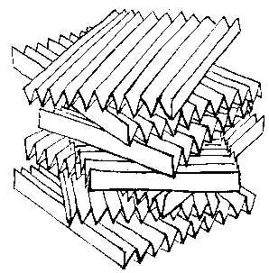
Cut apart-longways-5 sheets of office paper and fold each of them accordion-like so as to get 10 edges and 20 surfaces. Squeeze the accordions to make them square and glue them on top of one another, turning each horizontally 30 degrees clockwise against the bottom one.

Glue together, preferably out of dark paper, a conical, multi-layered "flower" with a few dozen petals; fluff up the petals.

Test the emanators with by putting your palm on above the "flower" and underneath the suspended "accordion". Place them above the head of the sitting person, marking his sensations.

Foam plastic. We are used to the fact that this excellent thermal insulator "reflects" the warmth of the hand even at a distance. But even if you cover it with dark paper, cardboard, or a tin plate, it would still do the same. This happens due to the work of multiple vesicular caverns of the material that produce the CSE.

Foam rubber. It is widely known that a person used to sleeping on, say, a cotton wool mattress doesn't sleep well at first on a rubber foam one, or else is unable to sleep at all. This is a typical manifestation of the CSE. Later on, the organism adapts itself to this new bed.

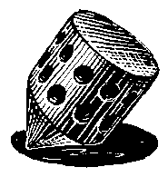
"Mushroom CSE". A hunter once told me that he warms up his hands in winter on bracket fungi. Let us recall that the lower horizontal part of this tree fungus is full of fine comb-tubes through which spores fall out in summer. What the hunter felt was not warm but a typical CSE.

Moving "combs".
Make a wooden whipping top and drill several through caverns on its sides, pencil-width in diameter or a bit wider. Their CSE significantly increases if the top is rotated; this is easily perceived by the palm.
This is due to the fact that the caverns must be numerically multiplying in space.

"Flower CSE". An "unnatural" position of such a seemingly common and pleasant object as a living flower can also change its properties. Put a bunch of several dozen bell-shaped flowers (tulips, narcissuses, lilies, bell-flowers) upside down above the head of a sitting person. To bar the impact of odors, put the flower bunch in a plastic bag. Write to me about the results.

Wind-fallen trees. One of my test subjects, a geographer, said to me after experiencing the effect of one of my "grids" that he had once had a similar sensation many years before, when he was passing a wind-fallen section of a forest. His head, ears, mouth, and the entire body felt something particularly unpleasant-the same thing he felt under my grid. This means that the abruptly disrupted shape of the normal multi-cavernous space of the forest for some time emanated waves unpleasant for humans.

Before the rain. Place a shower nozzle on a tap and run cold water. Slowly move your hand toward the drops coming from the sides: most people feel "warmth". In reality, this is the CSE reinforced by the movement of ever-new elements of the "multi-layered" grid-water drops and gaps between them. After practicing in the bathroom or kitchen, pick up an even stronger CSE from fountains and waterfalls. Even when the atmospheric pressure is high, the shroud of a distant rain creates a powerful CSE field that has its impact on a large area. Have you ever felt sleepy before the rain even in enclosed premises? The CSE cannot be screened.
"The CSE of a book".

Take a thick, preferably well-read book and place it upright on the edge of a desk with its back facing the direction of the sun (e.g. facing north at night).

Open the book and fluff up its pages as evenly as possible. In a few minutes (the CSE does not appear immediately, as it doesn't disappear immediately ether), pick up with your palm, tongue, or back of your head some of the sensations mentioned in this chapter.

This "tail", after some practice, can be picked up at a 2-3 meters' distance. It is also easy to verify that the "book CSE" is also non-screenable-ask someone to stand between the hand and the book.

"A large cone" with an artificial comb filling and three magnets at the back.
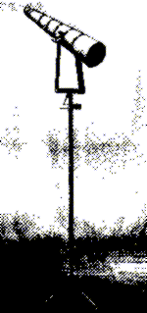
Two cones of this sort, positioned against each other taking into account the position of the sun, were in the morning of April 23, 1991, thrown apart and disfigured. One had been placed in Isilkul, the other near Novosibirsk (the second one was unfolded and pressed into the wall of an underground hiding place; its magnets disappeared).

At the same moment, residents of an Omsk apartment experienced a series of strangest "poltergeists" (see Vechernii Omsk for April 26 and Omsk and Moscow TV broadcasts). Because of this coincidence, on August 5, 1991, the same paper called the device in the picture "a Grebennikov's hyperboloid".

Actually, one of the "beams" of the upright electronic waves between the two structures may have been formed precisely there, on the Irtysh embankment in Omsk.

"A medium cone".

Tightly insert a dozen plastic household funnels into each other and fix the structure on any support with the nozzles turned toward the sun. Cover the bell end of the top funnel with a net or light blue cloth (so that the tested subjects not anticipate heat).

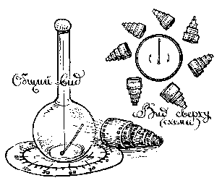
"A small cone". Tightly roll up two unusable rolls of film, tied them up with string or thread and make a bell-shaped cavity in the middle of the top roll. CSE emanations can be easily picked up by the palm, particularly in a counter-solar position. You will get interesting sensations if you press this "microcone" to your forehead.

"Perpetuum mobile".
I surrounded my above-described device [for registering CSE emanations; a straw indicator suspended on a cobweb thread] with seven funnel-shaped rolls of film [see above].

Slowly leaving the zone of impact of one roll, the straw would enter the power field of another, then the third, and so on...

This experiment is most successful in a sound-insulated chamber, away from wires, pipes, and sources of heat, cold, and bright light. There is no miracle here: matter is eternal in its endless movement.

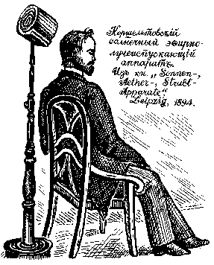
A solar ether- and beam radiator.
This intricate name was devised by the Leipzig professor Otto Kornschelt who discovered the CSE over 100 years ago and produced devices for its practical application in medicine, agriculture, and technology. Rhythmic caverns were formed in them by cooper chains.

The devices were positioned with their backsides facing the sun. It is indeed true that new inventions are simply well forgotten old ones. The sensations described by Kornschelt are identical to the ones I experienced in my own independent work.

I learned about Korschelt's experiments very recently from M. Platten's New Medical Technique, vol. III, St. Petersburg, 1886, where the following drawing of the device is reproduced.

"The sieve CSE". In the old days, in several areas headaches and concussion symptoms were treated with an ordinary flour sieve that was held above the head of the patient, net up. Alternatively, the patient squeezed the rim between the teeth, with the net in front of the face. The sieve material is unimportant. The device works better if the patient faces the sun (north at midnight). This type of CSE is also perceivable by healthy people.

The CSE and the planets. The planets of our Solar system are situated at certain distances from the sun. The Ticius-Bodet formula for the distance is this: 4 is added to the numbers 3, 6, 12, 36, etc (a geometrical progression), and the resulting number is divided by 10. The cause for this regularity is unknown. The empty spot in this progression (between Mars and Jupiter) is occupied by asteroids. The Kemerovo physicist V. Iu. Kaznev thinks that the regularity is determined by the CSE generated by the sun: the matter of planets was grouped in the areas of the sun's field force concentration.

The CSE in daily life. Perceivable waves of matter are emanated by piles of pipes, some caves, underground tunnels, tree crowns; the shape of premises is also significant (round, cornered, cupolaed). The wall and furniture material also emanates a CSE of certain parameters.

"Micro-CSE". The CSE effect may be manifested not just in galactic or household scales, but also in micro-world, in substances whose molecules have caverns of certain shapes. For example, in naphthalene. I filled a one-liter jar with it, sealed it, and suspended it from the ceiling. People beneath it felt with their palms a whole system of power field "clots". (more so, if the receptacle was suspended above the top of the head). Activated charcoal is also a multi-cavernous structure. Hold 2-3 tablets of such charcoal in your fingers as demonstrated in the picture and for a few minutes move your hands slightly up and down, or parting and joining them. Write to me about the results.

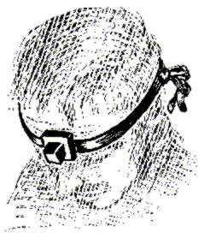
Tefelin.
I have so far isolated 4 CSE emanators beneficial for humans: bee honeycombs, a grid of joined hands (more about it in the next chapter), a sieve, a phylactery otherwise known as tefelin.

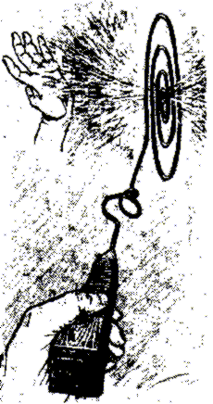
What is it? An old device: a tightly sown leather cube attached to a leather platform with two bands. Inside the cube there are four strips of parchment-tightly rolled, bleached, soft kidskin with Talmudic inscriptions. A worshippers attaches the device to his forehead, with the axes of parchment rolls perpendicular to the forehead and their outer ends facing East. It turns out, the inscriptions were unimportant; what matters is the material, shape, and dimensions.

Made of different materials, the device only causes unpleasant sensations, while a leather tefelin produces a beneficial physiological effect-besides the shape and other factors - the microstructure of the material must have a part in it too.

Thot's Scepter.

The ancient Egyptian deity Thoth is a god of science, sorcery, and an "accountant" of the dead's earthly deeds. This is the design of his staff: 2- or 3mm copper wire is twisted at the end in the shape of a flat spiral, with 3-4 coils, each 10 cm in diameter'; closer to the handle there are 2 coils of transverse, 3-dimensional spiral, each 5 cm in diameter.

The wire is inserted in the 16-cm-long square-sectioned handle of dense wood, 4 cm thick at base and 1.5 cm thick at its end; the entire staff with the wire is 41 cm long. The narrow end of the handle has 13 deep accordion-shaped cuts.

The staff works even without the wire (albeit not as strongly); the wire is thin and could be of any material but works best if thickly insulated-two layers increases its effect.

If you hold the staff as demonstrated in the picture, the total radiation emanating from the center of the large spiral, perpendicular to its surface, are very well-perceivable by the human palm on both sides.

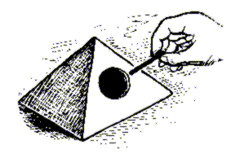
I never found out for what purpose ancient Egyptians used this "double-beam" emanator.

The Pyramid of Cheops.
Make a pyramid of 3-4 layers of thick, porous wrapping paper: 202x20 cm square base, ascending edges 19cm each. Glue it only at the edges, the tighter the better, but in a thin line.

Make a 5-6 cm hole in the middle of one of the side facets. Hold a 10 cm-long piece of drawing coal in your fingers, or simply a pencil, and insert this indicator into the hole, slanting the other end toward the bottom of the pyramid. "Stir" the space inside the pyramid with the indicator, take it out, then repeat the procedure about 30 times.

You will soon pick up an active zone-a "clot"-where the Egyptians had their tombs. Another active zone, above the top of the pyramid, is also well perceived by the indicator if you drag its end over he top. After some practice, the "clot" and the "torch" are well felt by the finger inserted into he pyramid, or a palm moved above it.
The pyramid effect that generated over the centuries many scary, mysterious stories is one of the CSE manifestations.

The pyramid skeleton.
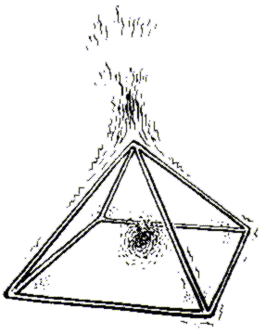
Similar interesting qualities are displayed by pyramids of the same dimensions but only skeletal, without facets-a skeleton glued together of 8 smooth, firm straws. Here we get the effect of the total CSE of the straws with their complex capillary structure and the effect of the entire cavern. Such pyramids can also be made in other sizes, with a proportional increase in the length of the edges.

Hold such a pyramid above the head of your friend, bottom down, for about 5 min... then bottom up. Conduct additional experiments with insects (bumblebees, developing caterpillars, etc.), hhouseplants and perishable foods by placing the latter within the pyramid, above and underneath it (always checking your experiments by identical ones but without the CSE effect). And you will see that ancient Egyptians had their reason to build pyramids...

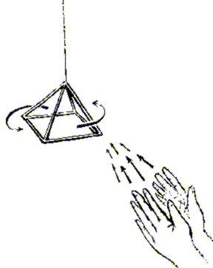
Telekinesis.

This is the name for a contactless movement of light objects of which the so-called gifted people are capable of moving – e.g. a match box on a table without touching it, holding a tennis ball in the air...

I submit that everyone has this ability. Suspend the described skeletal pyramid by its top from the ceiling on a thin, artificial thread, or better still on a long shred of elastic torn from a stocking. Choose a spot with the lowest convection (air circulation).

In a few hours, when the pyramid stops rotating, from a 2-meter distance point at it a "tube" made up of two hands (see picture). In a few minutes (do not lose your "target"), the pyramid will start rotating clockwise under the pressure of this beam of CSE energy. Stop the rotation by moving the "tube" to the right side of the skeleton-it will start rotating counter-clockwise.

Conduct experiments of various duration, after various time intervals and at various distance. You will see that telekinesis is no miracle, but only one of the manifestations of the Will of Matter that is available to a chosen few but to everyone. The thing is that the palm is also a multi-cavernous structure that clearly repels the indicator of the straw-cobweb device described in this chapter. By using it and the skeletal pyramid, you can practice and develop your "telekinetic" abilities, significantly increasing them.

"The CSE of cereals".
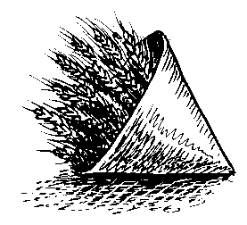
Fasten a bunch of 30-40 ripe wheatears, better with short stems, inside a low cone of dark paper-as in the picture.

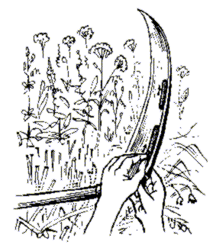
Hand-perceivable emanations repel the straw indicator of the same device through any screens-even sharper than some honeycombs.

This effect is produced by multiple wedge-shaped sinuses between ear scales that are directed at an acute angle toward the bottom of the ear.

Haymaking with "miracles".

In my youth, I was shown the following: a fragment of a cut stem, the length of a short pencil, was placed on the blade of a scythe, next to its blunt edge; another stem fragment of the same length, placed on the blade in the same manner but at some distance, was pushed by the hand to the first one.

At about 8cm, the first stem got moving, "ran away" from the second stem along the rim. The experiment wasn't always successful; it usually occurred right after the cutting a large amount of grass from the same spot; I forgot some elements or conditions of the experiment.

I think the following factors were at work here: an abrupt change of the total CSE field on the "deformed" meadow (let us remember the windfall case), the grid of the reaper's fingers, the multi-cavernous properties of the stem itself, and perhaps its position against the morning sun. Static electricity is excluded, as everything at that hour is wet.

Identified Flying Objects. A long time ago, in a remote Caucasus village, I was surprised that people walk around the mountains at night, through dense forests. They all had lit cigarettes in their mouths, are all waving their hands, and their cigarette lights for a second disappear behind their bodies.... It turned out those weren't cigarettes, but local fireflies, Luceola mingredica; their light twinkle in this manner. Meanwhile, UFO reports and letters from my readers tell of dark flying saucers that turn out to be either a flock of birds or a compact swarm of insects. I myself saw in Siberia not just "columns" of insects but also "balls", 3 or 4 meters in diameter: in one case those were some mosquito-like fliers, in another, winged ants of the Mirmica genus. From afar this swarm could by taken by an ignorant person for a huge, round plasmoid.

A detailed description of the CSE effect may be found in my book Mysteries of the World of Insects (Novosibirsk, 1990), in the journals Sibirskii vestnik selskokhoziastvennoi nauki, no.3, 1984, and Pchlovodstvo, no. 12, 1984. The physical nature of CSE is described in Non-periodic Galloping Phenomena in the Environment, vol. III (Tomsk, 1988). All in all I have published over three-dozen articles on the CSE.

As promised, I will describe the rest in my next book. I will call it as I called this chapter: Flight.

Viktor S. Grebennikov died at the age of 74 in April 2001.

This information was received via e-mail from a friend in Russia by the name of Youlain who sent in the URL some two years ago. When I saw the pictures of the platform, especially the one hovering over the ground I thought it was a hoax, but I couldn't stop thinking about it so translated the webpage in sections beginning with the technical descriptions.

As correlations began to fall into place, I hesitated reporting it because his writing indicated psychogenic effects associated with these structures, meaning it could be hallucinations, delusions or daydreams perpetrated with jumping into the air while on the platform as what the TMers (Transcendental Meditation) devotees claim as 'flight'.

However, other aspects of his claims led me to think he really had discovered something. With the idea of getting a copy of the book, I ended up sending some $200 to Yuri with the instructions being to take out the cost of the book and shipping, give the rest to the Professor. I did receive the book (Youlain bought his for $7.00 US but he lives in Russia.)
Meanwhile, I had made a 'secret' page on KNet whose URL I mailed out to long time trusted confidants to see what they thought about it since I valued their insights, opinions and knowledge, asking them to keep it on the QT until I heard from the professor direct, if possible. From their responses, new information was added.

However, one of these long time confidants who over the years since the BBS days, shared much useful information, had now become infatuated with public attention and so posted the URL and claimed I was 'hiding' information in order to further his newfound career of public speaker and author. Very sad to see this but ego just took him over, so he's gone.

In the meantime, Yuri had kindly provided me with the Professors mailing address and I immediately wrote to him in Russian, sending at least 5 packets over the next year of correlated information to him and all translated into Russian.

In all that time I received only one letter from the Professor, which stated he had suffered a stroke, that he had no degree and had learned what he knew from his experiences in 'gulags' (Russian prison of war) and was paralyzed on one side, having to type this letter with one finger. At the time of his response, he wrote he had received 3 of my letters, indicating in the letter that his son had withheld the ones I sent in February until May before he actually saw them.

I asked his son, Sergei, in the phone call why they had not responded with but one letter in the past 2 years and he said the entire family had been ill, especially his father. Early in 2001 I asked Yuri if I flew over there and pre-arranged an interview with Professor Grebennikov, would he serve as translator and he agreed, that was roughly in February. It was only when I called Sergei in July, after the June KNet conference, that I learned Professor Grebennikov was deceased.

The Professor had written that he would like me to republish his book in English and so I was trying to get him to sign a copyright release to pursue that project. After his death, the rights would have gone to Sergei, so I asked him if he would be willing to sign such a release for a percentage of book sales and he didn't seem to comprehend the matter over two phone calls and a detailed letter with release form. The calls were made in Russian as translated by my Russian translator Helena. She also wrote and sent the letter with copyright release to which Sergei has not responded, as of December 6th, 2001.

It takes about two to three weeks for a letter to get from Dallas to his village near Novosibirsk and the same to get back. They don't offer UPS, FedEx, or any faster means of snail communication and the Professor was not online... relegated to living on $24.00 US per month in his retirement. That is another reason I was considering publishing his book, as his percentage would greatly improve his income level, which is irrelevant now.

In the book, of the sections we have in English, he asks only to be recognized by his peers and in the history books as the discoverer of the CSE phenomenon. He has of course refused to reveal the name of the insect and even the genus... it could be a beetle, a butterfly, a bee, a wasp, a locust, a grasshopper, a dung beetle. There are some 1100 species of beetles in Russia.

Professor Grebennikov was a great ecologist as you can tell by his protective attitude toward the environment. He was afraid if the name of the insect were revealed, people would rush to the area and kill off all of them. I wrote him in two separate letters that it was not necessary to know the insect name or genus.

In order to allow verification, all we needed were TWO of the insect covers which could be analyzed under an electron microscope to determine geometry and dimensions, from that point, it should be possible to duplicate it artificially and the insect would be forever safe.

I offered the Professor $1,000 US in cash if he could send me two of the covers (I sent money to pay shipping) AND they exhibited the gravity repelling characteristic he had seen. He indicates the effect was not magnetic, electrostatic or due to stray air currents.

He never responded which his son claims was due to illness.

At any rate, the entire book is currently being translated and my current plans are to extract technical information and compile it with other information, which correlates and supports what the Professor claims.

This will be sold through KNet to recover my personal expenditures and to support KNet along with further research, donations are greatly appreciated

There is a lot of weirdness going on with this. I asked Sergei if he could provide a couple of the covers, he said he didn't know what they were or where they came from. I then asked him what happened to his fathers flying platform, he said (in a hesitant and halting fashion) his father had hidden it and he didn't know the location.

We have since read an email from a Russian scientist who visited Professor Grebennikov in the hospital and claims he was told firsthand that he had smashed the platform to pieces. Sergei also said many people had been contacting he and his father since the publication of the book some 6-7 years ago, with everyone wanting the secret, but his father had never revealed it.

Numerous posts have been made to the KNet Interact discussion list on cavities, nanostructures, arrays, chitin, dielectrics and related subjects for those who are interested in this claim.

Additional information has been posted in the Chaos file, the Time Dilation file and in dual presentations (Decker & Davidson) made at the June KNet 2001 conference in Dallas (available on videotape) See also Jerry Decker for posting to the list, thanks!

Additional fascinating information relating to weight loss in sleepwalkers was provided by Slavek Krapelka and with full details posted at his website at;
Amazing Sleepwalking Experiments.
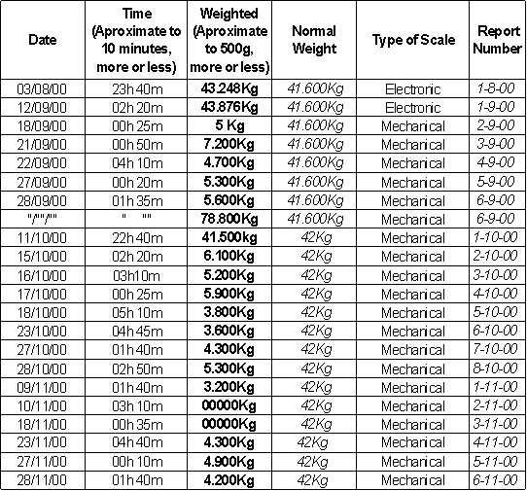
Again, we want to publicly acknowledge the efforts of Slavek Krapelka and Ren Berghuis for spending the $300.00 to get the Chapter 5 file translated and passing it on.

If you would like to contribute something to help them recover their costs, please send an email to Ren Berghuis for information on how to do so. THANKS!!!

So FEW people actually contribute with anything more than comments or looking for free material researched or validated by others.

There is more information, which will be added to this page or linked in future.
Additional information from our translator that might be of use;
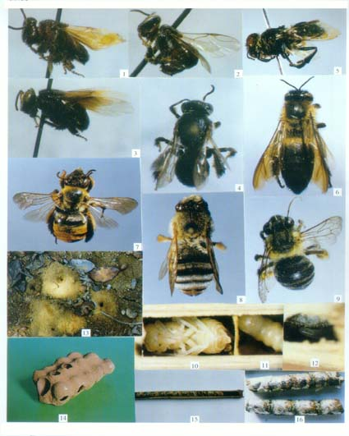
"The only specific insect I've seen mentioned thus far of possibly interest was the one I identified in the portion of the 'Flight' chapter you saw, the bee, 'Halictus quadricinctus'. It seems that particular subspecies is native to Siberia, although most of the other references sound fairly generic."
A picture of the mudnest and the Halictus Quadricinctus photos I found on the web;

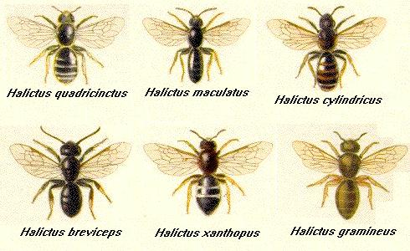
1. Trigona (Heterotrigona) lutea Bingham
2. Trigona (Heterotrigona) laevicpeps Smith
3. (Micrapis) florea Fabricius
4. Trigona (Heterotrigona) vidua Lepeletier
5. Ctenoplectectra davidi Vachal
6. Apis (Megapis) laboriosa Smith
7. Eucera pekingensis Yasumatsu
8. Tetralonia chinensis Smith
9. Habrophotula nigripes Wu
10. (pupae)
11. (larvae)
12. Xylocopa (Biluna) tranquabarorum (Swederus)
13. Halictus camellia Wu
14. *** Halictus quadricinctus Fabricius ***
15. ??
16. Osmia excavata Alfken

